**DAILY ONLINE ACTIVITIES SUMMARY**

|  |  |  |  |  |  |  |  |  |
| --- | --- | --- | --- | --- | --- | --- | --- | --- |
| **Date:** | **20/05/2020** | | | | | **Name:** | **V ANJANA PAI** | |
| **Sem & Sec** | **IV sem & B section** | | | | | **USN:** | **4AL18CS094** | |
| **Online Test Summary** | | | | | | | | |
| **Subject** | | **OBJECT ORIENTED CONCEPTS** | | | | | | |
| **Max. Marks** | | **30** | | **Score** | | | **18** | |
| **Certification Course Summary** | | | | | | | | |
| **Course** | **Python for Machine Learning** | | | | | | | |
| **Certificate Provider** | | | **Great learning academy** | | **Duration** | | | **5.0 hours** |
| **Coding Challenges** | | | | | | | | |
| **Problem Statement1:** [Write a C Program to Reverse a Linked List (SLL) in groups of given size.](https://github.com/orgs/alvas-education-foundation/teams/2nd-year/discussions/67)  Test Case 1: If a linked list: 1 → 2 → 3 → 4 → 5 → 6 → 7 → 8 The value of size k is 2 Then the linked list looks like: 2 → 1 → 4 → 3 → 6 → 5 → 8 → 7  Test Case 2: If a linked list: 1 → 2 → 3 → 4 → 5 → 6 → 7 → 8 The value of size k is 3 Then the linked list looks like: 3 → 2 → 1 → 6 → 5 → 4 → 8 → 7  **Problem Statement2:** Write a C or Java program to implement FCFS and SJF process scheduling. Input: Processes with burst time Output: Process being scheduled | | | | | | | | |
| **Status: Executed** | | | | | | | | |
| **Uploaded the report in GitHub** | | | | | **YES** | | | |
| **If yes Repository name** | | | | | **lockdown-coding** | | | |
| **Uploaded the report in slack** | | | | | **YES** | | | |

Online Test Summary: 18CS45 test was scheduled from 9:30 am t0 10:00am. The portion for the IA was 1st module there were 30 questions and the time assigned was 40 minutes the questions were mcq type and to predict the output of the given program.

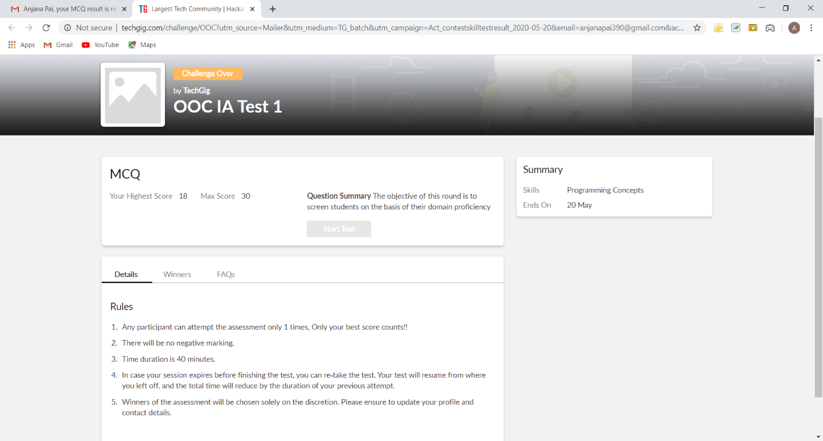

The above snap shot is the completion of the test and the marks allotted.

Online Certification Course Summary: In today’s session I have learnt about some of the special data structures used in python apart from int, float string and Boolean. In this session I came to know about list and how it works in python and that list which stores multiple values and we can also insert and remove element from the lists and I also learnt about some more data structures like to check maximum and minimum, checking of element in the list, appending multiple value for the list etc.

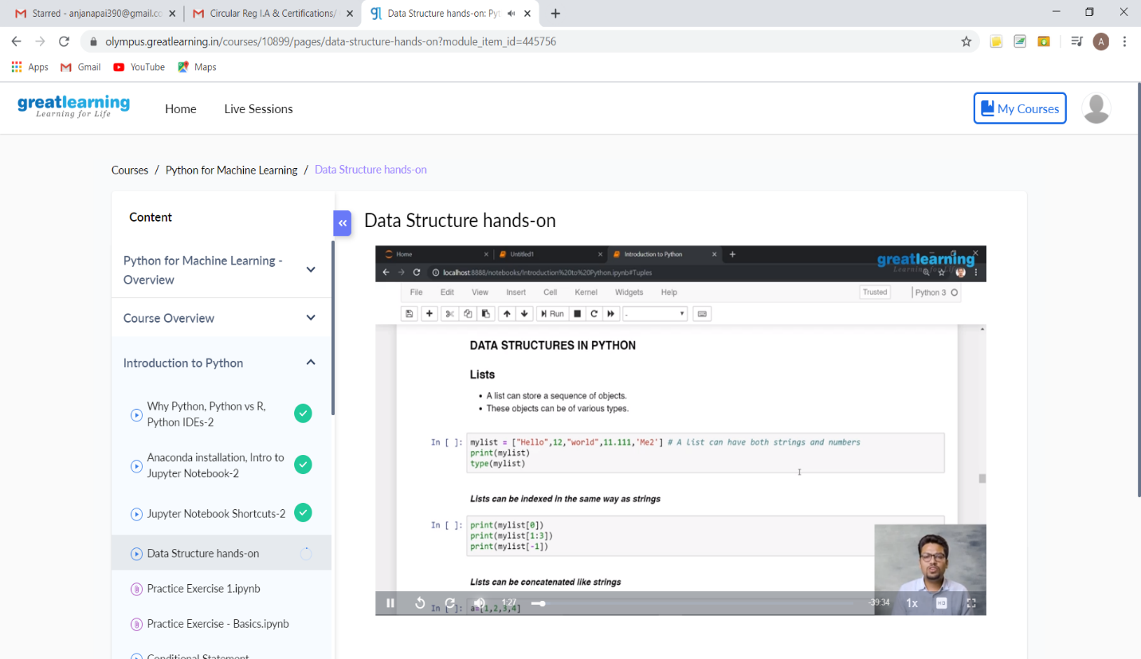

And also learnt about tuples, dictionaries, sets and difference between lists and tuple etc.

Online Coding Summary: **Today I had received one program from prof. Venkatesh CSE Dept. and the other from prof. Harshitha CSE Dept the programs are mentioned above in the coding challenges(pg.01). I have also uploaded it to my GitHub repository.**

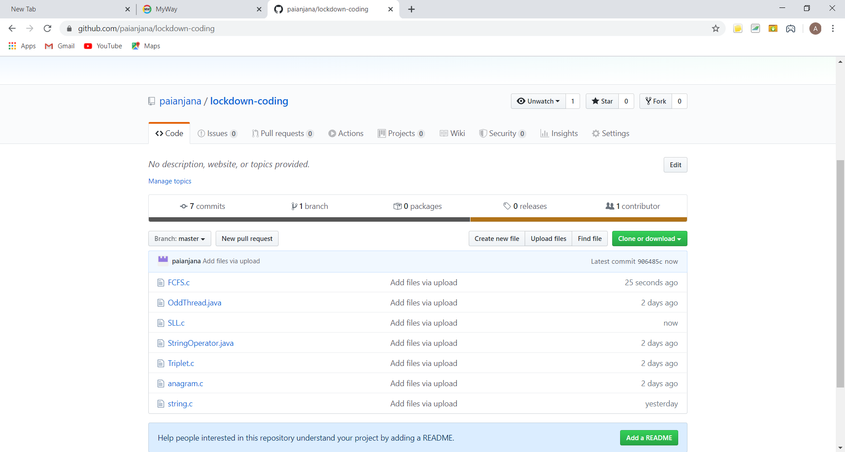

It is the snap shot of my repository where I have uploaded the code. File name is SLL.c and FCFS.c